***Dhanush kumar.K***

***731621106008***

***KSRIET***

**Exercise 4:**

1. Make a commit, and make a silly typo in the commit message.

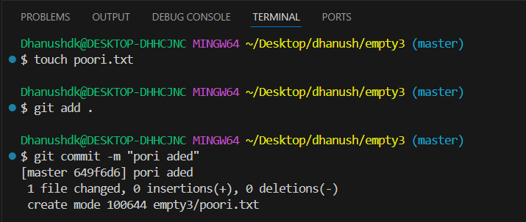

2. Use the --amend flag to enable you to fix the commit message.

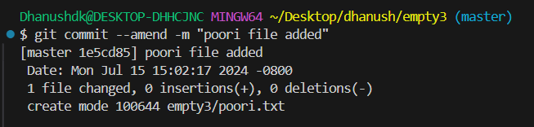

3. Look at the log and notice how the mistake is magically gone.

4. Now make a commit where you make a typo in one of the files. Once again, use --amend to magic away your problems.

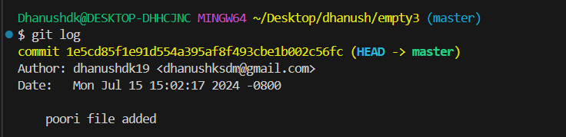

5. Create a branch. Make a commit.

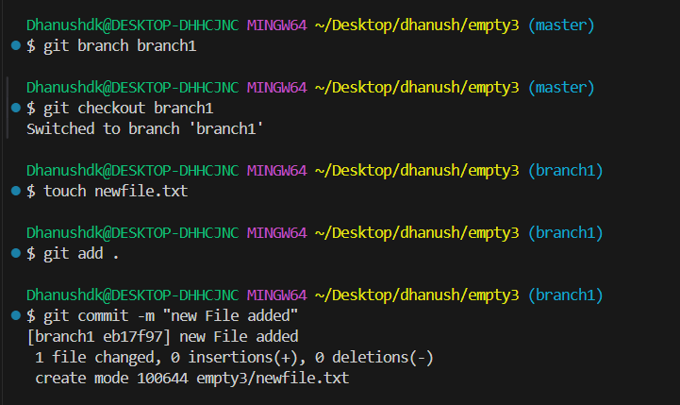

6. Now switch back to your master branch. Make a (non-conflicting) commit there also.

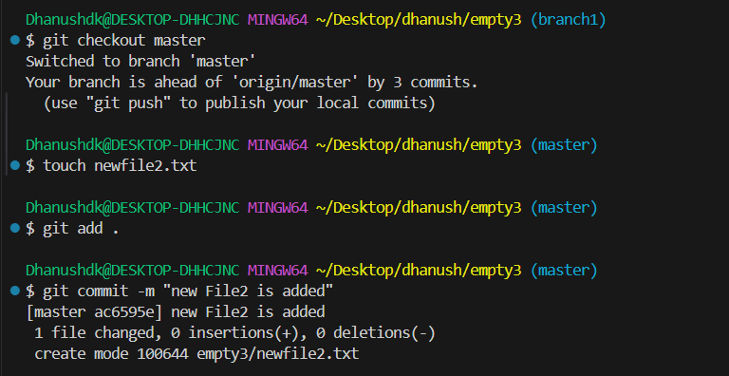

7. Now switch back to your branch.

8. Use the rebase command in your branch. Look at the DAG in gitk, and note that you have the commit from the master branch, but no merge commit.

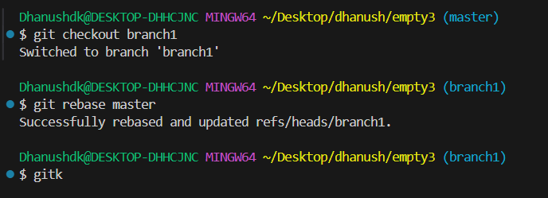

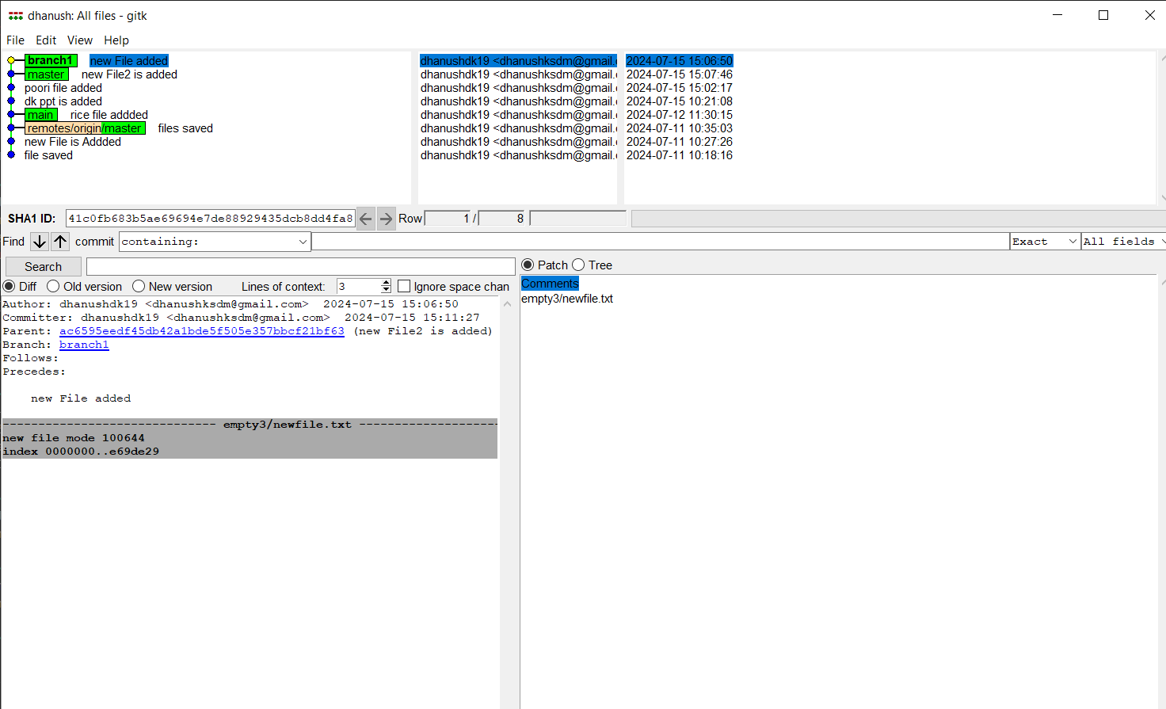

9. Make one more commit in your branch.

10. Return to master. Merge your branch. Notice how, thanks to the rebase, this is a fastforward merge.



